John Garcia’s Module 1.2 Assignment

Github Repo link: <https://github.com/RUKtheCROOK/CSD-340>

Local Directory Screenshot:

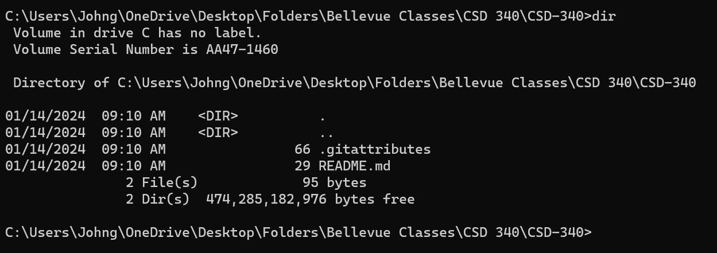

Github Repo Landing Page Screenshot:

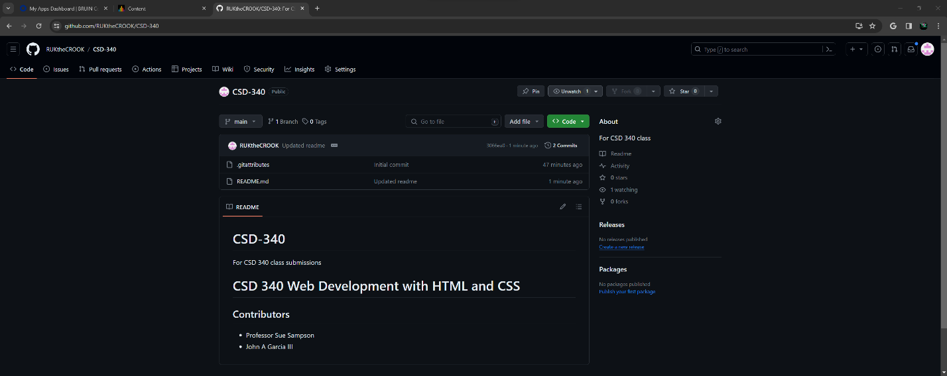

Note: I did leave “CSD-340 For csd 340 class submissions” in the read me file for my records.